CH-1
1. Given an array of strings words, return the first palindromic string in the array. If there is no such string, return an empty string &quot;&quot;. A string is palindromic if it reads the same forward and backward.
Example 1:
Input:
def first_palindrome(words):
for word in words:
if word == word[::-1]:
return word
return ""

n = int(input("Enter the number of words: "))

words = []

print("Enter the words:")
for i in range(n):
words.append(input())

result = first_palindrome(words)

print("First Palindromic String:", result)

output:
Example 1 :
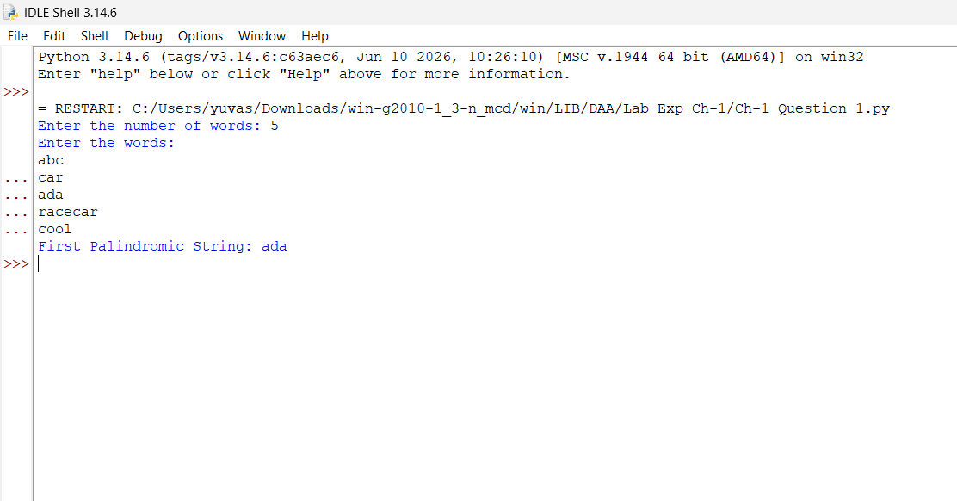
Example 2:
